MULTIPURPOSE AGRICULTURAL VEHICLE

# B.Dhanasakkaravarthi1, Logeshwarar.V2, Hemanathan.M3 , Lokesh.N4

*1 Associate Professor, Department of Mechanical engineering, Panimalar institute of Technology ,Chennai, India.*

*234 UG Scholar, Department of Mechanical Engineering, Panimalar Institute of Technology, Chennai, India*

---------------------------------------------------------------------***---------------------------------------------------------------------

**Abstract -** Agriculture is a back bone of India .In today’s competitive world there is need of faster rate of production of agriculture products and also develop multipurpose agricultural vehicle for performing major agricultural operations plough like plough and row making. In India almost all farmers facing problem of labour shortage. The modification includes fabricating a vehicle which is small, compact in size. The project is about a machine design which makes cultivation much simpler. The design of the chassis of the vehicle is made in such a way that it is suitable for the operations. The plough is designed and modified the currently available plough tool in such a way that it with stand the load. It consist of engine, chain sprocket mechanism, gear arrangement for power transmission to rear wheel to the move the vehicles, plough for breaking soil and using to make row in agriculture field. It also uses to save of time as will as expenses towards field operation .It can be used for all fields.

***Key Words*:** Ploughing, Row making Ploughing, Harvester Chassis, Cultivation, Agriculture, Chain, Operation, Sprocket, Engine, Save Money, Save Time.

1. **INTRODUCTION**

Development in agriculture leads to raise economic status of country. The study of agriculture is known as agricultural science. The history of agriculture dates back thousands of years, and its development has been driven and defined by greatly different climates, cultures, and technologies. Modern agronomy, plants breeding, agrochemicals such as pesticides and fertilizers, and technological developments have in many cases sharply increased yields from cultivation, but at the same time have caused widespread ecological damage. Agricultural food production and water management are increasingly becoming global issues. Mechanized agriculture is the process of using agriculture machinery to mechanize the work of agriculture, greatly increasing farm worker productivity in modern times, and powered machinery has replaced many farm jobs formerly carried out by manual labour or by working animals such as oxen, horses and mules. In India formers are facing problems due to unavailability of labours, traditional way of farming using non efficient farming equipment’s which takes lot of

time also increase labor cost. In is very essential to discover and implement new idea in this field, though lot of work has been done in this area. This ideas are not been implemented properly in actual field. Conventional method of plough and row making and cultivation in laborious process and hence for that reason there is a scarcity of labors, this in delayed agriculture to overcome these difficulties, multipurpose agriculture equipment is designed. Agriculture plays a vital role in the India economy. The share of agriculture in GDP (**GROSS DOMESTIC PRODUCT)** increased to 19.9 per cent in 2020-21 from 17.8 per cent in 2019-20. The last time the contribution of the agriculture sector in GDP was at 20 per cent was in 2003-04. Agriculture employed more than 50% in India. The major problems in India agricultural are rising of input cost.

The automatic in the agriculture could help formers to reduce their efforts. The industrial revolution has allowed farming to become much less labour intensive current mechanized agriculture includes the use of tractors, trucks, combine harvesters, countless types of farm implements, airplanes and helicopters and other vehicles. The proposed idea implements the vehicle to perform the functions such as ploughing, row making ploughing. These functions can be integrated into a single vehicle and then performed.

## SCOPE AND OBJECTIVE

* 1. **SCOPE OF PROJECT**
     + This vehicle is designed to be of lower cost to the conventional tractors.
     + This vehicle can do both ploughing and row making as of the conventional tractors, but instead of the usual ploughing methods the vehicle uses a simplified mechanism to plough land in an efficient manner.
     + The vehicle proposed in the project is just an initial prototype, we are looking forward to enhance our system in a way that it can aid low budget farming.

## OBJECTIVE OF PROJECT

* + - The primary objective is to create a vehicle that can alternate the purpose of a tractor at a comparatively lower cost.
    - The other objective is to create a vehicle to motivate low budget farming.

## METHODOLOGY 3.1 METHODOLOGY

In this project the idea is to fabricate small scale tractor. Different part of a machine will be mounted on the strong chassis. The rear wheels will be attached to chassis with the help of shaft supported by the two bearing, so that the vehicle can be moved in the farms. The staring is provide at all front of chassis to control the direction of the vehicle having front wheel. The 4-strocke petrol engine is mounted on the chassis which provides to the rear wheels with the help of chain Sprocket. With are mounted over a policed shaft .At very end of chassis the driving vehicle is attached which has a shaft supported by two bearings where a small sprocket is attached which is driven by engine with help of chain drive. The end of back chassis set of ploughed farm will be locked with help of bolt & nut by chassis.

#### 3.2 CHASSIS OF VEHICLE

The choice of material for the vehicle is the first and most important factor for automotive design. There is variety of materials that can be used in automotive body and chassis. The most important criteria that a material should meet are lightweight, economic effectiveness, low cost, safety, recyclability, and life cycle consideration. Some of these criteria are the result of legislation and regulation. The material for the frame and chassis is steel. The main factors for selecting material specially for body is wide variety of characteristics such as thermal, chemical and mechanical resistant which are ease for manufacturing and durability. In the frame only the main supporting structures such as engine of the vehicle, the row maker and ploughing tool are mounted. It support the tool static and dynamic load of the vehicle.

## DESIGN

A design is a plan or specification for the construction of an object or system or for the implementation of an activity or process, or the result of that plan or specification in the form of a prototype, product or process. The verb to design expresses the process of developing a design.

## DESIGN OF FRAME

The design is made which is suitable supporting all the operation. The frame is made for a compact size vehicle.

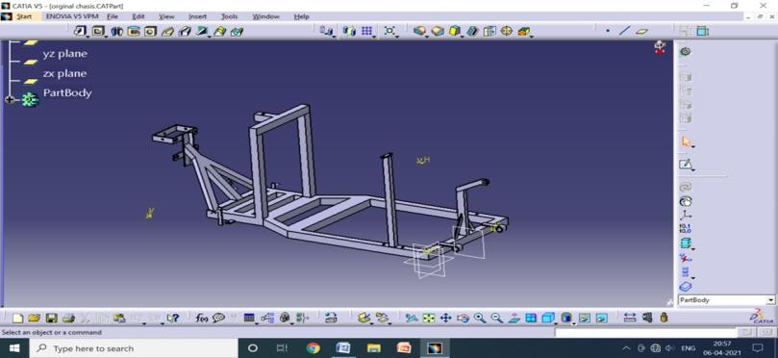

*Fig: 4.1 DESIGN OF FRAME*

## DESIGN OF PLOUGHER

The Ploughing tool is designed in the way that it wouldn’t break due to the sudden encounter of rocks and roots present in the soil. The faults in the current tool is changed and modified. The designed new tool is durable and affordable and can be used in all kinds of geographical region.

Engineering Design is the process of designing a system component or process to meet desired needs. It is the decision-making process (often iterative) in which the basic sciences, mathematics and engineering sciences are applied to convert resources optimally to meet a stated objective. Among the fundamental elements of the design process are the establishment of objectives and criteria, syntheses, analysis, construction, testing and evaluation.

## DESIGN OF PLOUGHER

The life of the tool is increased by replacing the only the tip of the tool. The sharpness of the tool is remains constant for significantly longer period of time. The efficiency and the effectiveness of the tool is increased. The optimum weight of the tool is obtained. The breakage of the tool is reduced by using high speed steel in the tip. The material used for plough tool is High Speed Steel.

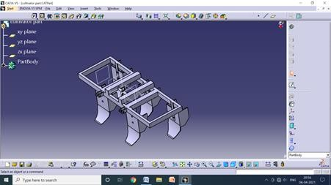 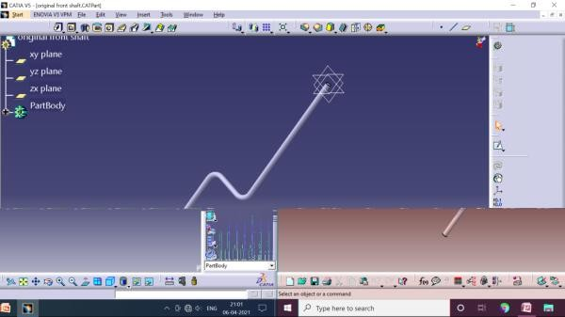

Fig:4.2 DESIGN OF PLOUGHER

## DESIGN OF SHAFT

* 1. **ANALYSIS**

Fig:4.4 DESIGN OF SHAFT

A shaft is a rotating member usually of circular cross-section (solid or hollow), which transmits power and rotational motion. Press fit, keys, dowel, pins and splines are used to attach these machine elements on the shaft. The shaft rotates on rolling contact bearings or bush bearings

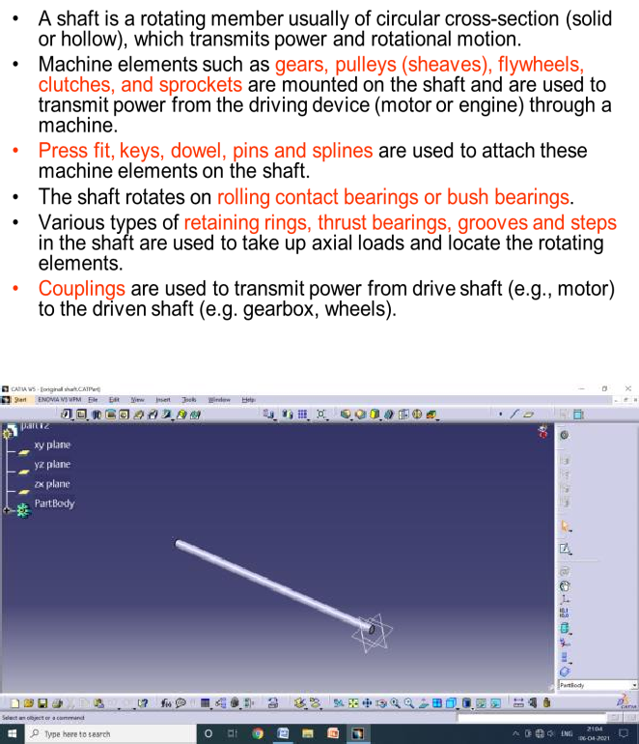

Fig:4.3 DESIGN OF SHAFT

Analysis is the systematic process of developing a design including all information discovery, planning and communications. This can be applied to any type of design including the design of physical things such as buildings and intangible things such as software, information and processes.

## STRUCTURAL ANALYSIS OF CHASSIS

An important consideration in chassis design is to have adequate bending stiffness for better handling characteristics. Structural systems like the chassis can be easily analyzed using the finite element techniques. So a proper finite element model of the chassis is to be developed. The chassis is modeled in ANSYS.

Chassis should be rigid enough to absorb the shock, twist, vibration and other stresses.

The critical consideration for chassis design is resistance to bending and torsional stiffness apart from strength for better handling characteristics.

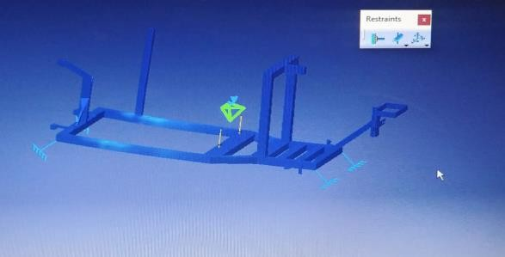

Fig 4.5 ANALYSIS (500kg)

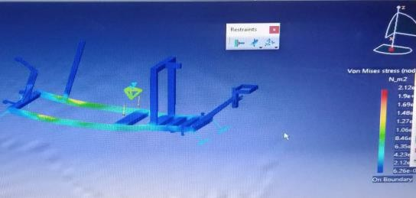

Fig 4.6 ANALYSIS (750kg)

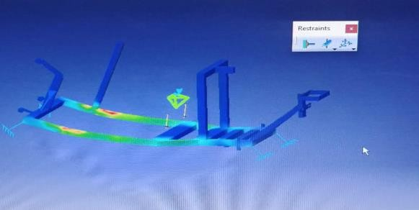

Fig 4.7 ANALYSIS (900kg)

## FABRICATION & ASSEMBL

* 1. **CHESSIS OF THE VEHICLE**

The chassis of the vehicle is made of iron square section of 40*40 mm dimension. The section is cut and welded according to the given design dimension.

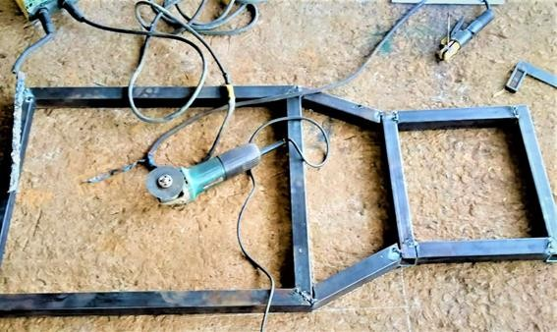

Fig:5.1 CHESSIS OF THE VEHICLE

## PLOUGHER TOOL AND FRAME

The design of the assembled components includes the ploughing tool, which are mounted on the vehicle frame.

The plough tool is fabricated using high speed steel. The tool is machined by cutting and grinding operations. The tool is fixed to the plough frame and various supports were given in

the frame for fixture of the plough frame in the vehicle. A separate hook and lever is attachment is given so that it prevent the motion of the plough in outward direction. The tool and the frame are welded using metal arc welding.

A plough or plow is a farm tool for loosening or turning the soil before sowing seed or planting. Ploughs were traditionally drawn by oxen and horses, but in modern farms are drawn by tractors. A plough may have a wooden, iron or steel frame, with a blade attached to cut and loosen the soil.

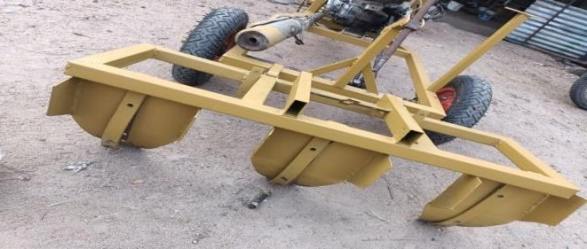

Fig:5.2 PLOUGHER TOOL AND FRAME

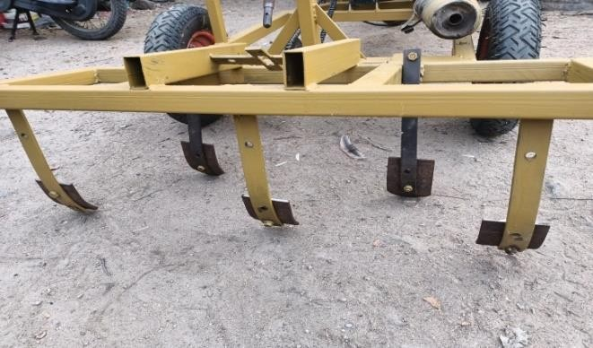

Fig:5.3 PLOUGHER TOOL AND FRAME

## ENGINE SPECIFICATION

An engine or motor is a machine designed to convert one form of energy into mechanical energy. Heat engines convert heat into work via various thermodynamic processes.

Displacement 106 cc

Engine Type 4 Stroke, Air-Cooled Single Cylinder SOHC

Max Torque 7.5 Nm @ 6000 rpm Max Power 7.6 bhp @ 7500 rpm Mileage (ARAI) 70 Kmpl

Cooling System Air Cooled

Starting Kick Start Only Fuel Supply Carburetor Clutch Wet, Multiple Disc. Ignition CDI Transmission Manual Gear Box 4 Speed

Bore 49 mm

Stroke 56 mm

Compression Ratio 9.0:1

### Max Speed 84 Kmph

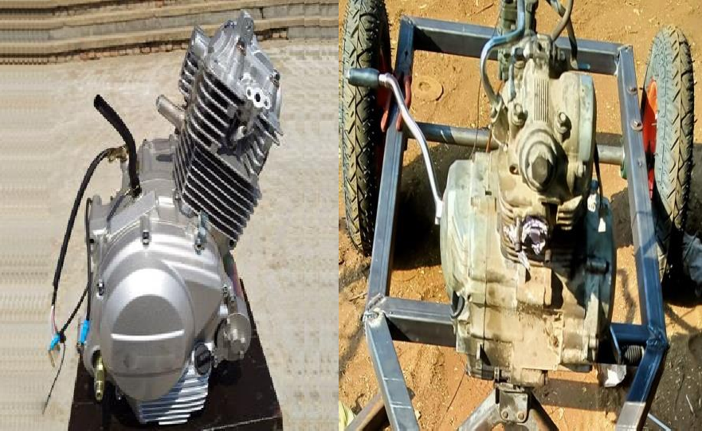

Fig:5.4 ENGINE

* 1. **Assembled View of Vehicle:** The separately fabricated components are assembled in the vehicle frame. The harvester is attached to the front. The plough tool is attached with the clamp at the backside of the frame. The seed sowing machine is attached in respective place.

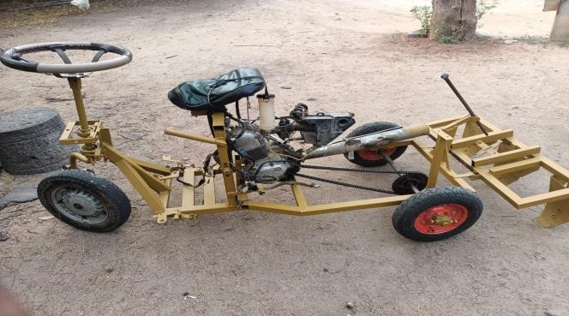

Fig:5.5 VEHICLE

#### Calculation:

* 1. Design Calculation for Shaft

Power of the engine, P = 10.297 kW Displacement = 149 cc Power, P = 2πNT/60 10297= (2 * 3.14 * 8000 * T)/60

Torque, T = 13.4 Nm = 13400 N-mm Now T is the maximum torque among all shaft, checking the shaft for failure T= (π/16) * 135 * d3 13400= (3.14/16)x135xd3 D = 7.96 = 8

mm

* 1. Bending Stress Calculation of the Axle Shaft Consider the weight of 1500 N is acting on the shaft, Induced stress, σ = M/Z Moment, M = (WL)/4 Where, W = load; L = Length M = (1500 * 1100)/4 M = 412500 N/mm Section modulus, z = (π/16) * d3 Z = (3.14/16) * 353 Z = 8414.21 mm3 σ = (412500/8414.21) σ = 49.02 N/mm2 Therefore, Induced stress < Allowed stress 49.02 N/mm2< 270 N/mm2 ( Hence the design is safe).
  2. Calculation for Plough Depth of cut= 5 cm Speed of the tool= 2.5 km/hr = 41.66 m/hr No. of tool= 4 Feed rate= Rpm x N x CL FR= 41.66x4x0.05 Feed rate, FR= 8.332 m2/min
  3. Tool Life Calculation From Taylor’s tool life equation, vTn= C Where, v= velocity T= tool life C,n= Taylor coefficient For HSS, n=0.2 V= 41.6 m/min 41.6xT^n=100 T=

2.4x10^20cycles For mild steel, T= 2.4x10^10 cycles.

|  |  |  |  |
| --- | --- | --- | --- |
| COMPONENTS | NO.OF COMPONENTS | COST OF COMPONENT | TOTAL COST(RS) |
| ENGINE | 1 | 2500 | 2500 |
| BEARING | 6 | 220 | 1320 |
| CHAIN SPROCKET | 1 | 900 | 900 |
| SHAFT | 2 | 320 | 640 |
| WHEEL | 3 | 1200 | 3600 |
| PLOUGHER TOOL(BIG SIZE) | 3 | 300 | 900 |
| PLOUGHER TOOL(SMALL SIZE) | 5 | 88 | 440 |
| CABLE | 3 | 150 | 450 |

7 CONCLUSION

|  |  |  |  |
| --- | --- | --- | --- |
| Iron square | 1 | 1200 | 1200 |
| BOLTS AND NUT | 50 | 5 | 250 |
| SEAT | 1 | 400 | 400 |
| STEERING | 1 | 800 | 800 |
| SPRING | 1 | 600 | 600 |
| SHOCK ABSORBER | 1 | 600 | 600 |
| FUEL CAN | 1 | 200 | 200 |
| WIRIING KIT | 1 | 700 | 700 |
|  | | TOTAL | 15500 |

This project entitled Design and Fabrication of Multipurpose Agriculture Vehicle is successfully completed and the results obtained are satisfactory. It will be easier for the people who are going to take the project for the further modifications. It very useful for small scale farmers. The cost can be reduced by using this type of vehicle. The agricultural operations is made easier. The reduction in cost of the plough tool is done and the life is also increased.

7.2 FUTURE WORk More operations can be included to the

[3]. Girish and Srihari, “Design and fabrication of multipurpose farm equipment”, International Journal for Scientific Research & Development| Vol. 4, Issue 06, 2015.

[4]. Suraj V Upadhyaya, VijayaVittalaGowda G, Poojith M B, Vikranth, “A Review of Agricultural Seed Sowing”, International Journal of Innovative Research in Science, Engineering and Technology.

[5]. Dr. C.N.Sakhale, Prof. S.N.Waghmare, “Multipurpose Farm Machine”,International Research Journal of Engineering and Technology (IRJET) e-ISSN: 2395 -0056 Volume: 03 Issue: 09 | Sep-2016 [www.irjet.net](http://www.irjet.net/) p-ISSN: 2395-

0072.

[6].V.M. Martin Vimal1, A. Madesh, S.Karthick, A.Kannan, “Design and fabrication of multipurpose sowing machine”, International Journal for Scientific Research & Development| Vol. 5, Issue 04, 2015

[7]. SaurabA.Bobde, RohitV.Gajapuri, “A Review on Solar Operated Agri Cutter”, International Journal for Innovative Research in Science & Technology, Volume 3, Issue 09 , February 2017.

vehicle like pesticide sprayer, tiller and many other machines for various operation. The engine of the vehicle can be replaced with diesel engine. The seed sowing machine is made with simple mechanism. The tyre can be changed according to the type of the land. The plough tool tip arrangement is made separately, so in case of breakage the tip of the tool is alone changed. The collection system of the harvester can be made more efficiently.

REFERENCES

[1]. M. Kamaraj, Akshay Kumar Chhabria, Kartick Kumar, Nishant Kumar, “Design and Fabrication of Multi-Purpose Farming ToolsEquipped”, International Journal of Innovative Research in Advanced Engineering (IJIRAE) ISSN: 2349-2163 Issue 05, Volume 4 (May 2017).

2].M.V.Achutha, Sharath Chandra, Nataraj.G.K. ,“Concept Design and Analysis of Multipurpose FarmEquipment”, International Journal of Innovative Research in Advanced Engineering (IJIRAE) ISSN: 2349-2763 Issue 02, Volume 3

(February 2016).

[3]. Girish and Srihari, “Design and fabrication of multipurpose farm equipment”, International Journal for Scientific Research & Development| Vol. 4, Issue 06, 2015.

[8]. Meselhy, A. A, “Design and Performance Evaluation of Circular Chisel Plow in Calcareous Soil”, International Journal of Emerging Technology and Advanced Engineering, Volume 4, Issue 11, November 2014.

[9]. P.Amrutesh, B.Sagar, B.Venu, “Solar Grass Cutter With Linear Blades By Using Scotch Yoke Mechanism”, International Journal of Engineering Research and Applications, Vol. 4, Issue 9(Version 3), September 2014

[10]. Ms. TruptiA.Shinde Dr. Jayashree. S. Awati, Design and Development of Automatic Seed Sowing Machine, International Journal of Electronics and Communication Engineering - (ICRTESTM) - Special Issue – April 2017.